International Joint Symposium
post russia-ukraine war:
the security perceptions of turkey and taiwan
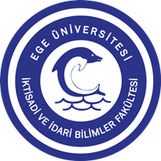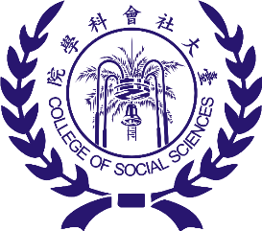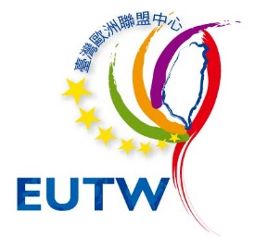
========================================================================================
The international joint symposium on “Post Russia-Ukraine War: The Security Perceptions of Turkey and Taiwan” is aimed at evaluating and debating the trends, complex patterns, and global implications of a changing security order by looking through the security perceptions of Turkey and Taiwan, both of which are challenged with multifaceted crises and risks in their regional security complexes.
The symposium is a pioneering international academic meeting for the discussion of global/regional developments under the collaboration of the Department of International Relations of Ege University; the College of Social Sciences of National Taiwan University; National Chengchi University; and the EU Centre in Taiwan (EUTW).
========================================================================================
Date: 04 October 2022
Time: 09:30-12:30 Izmir-Türkiye / 14:30-17:30 Taipei-Taiwan
Platform: Webex
To Join the Symposium Please Register and Fill in the Form at: https://forms.gle/Y9TyzmPYwXm1ohk8
========================================================================================
Participants:
Chair:
- Assoc. Prof. Ching-An CHANG
Dept. of Arabic Language and Culture, National Chengchi University, Taiwan
Presentations:
- Assoc. Prof. Altuğ GÜNAL & Assoc. Prof. Sinem ÜNALDILAR KOCAMAZ
Dept. of International Relations, Ege University, Turkey
- Assoc. Prof. Feride Aslı ERGÜL JORGENSEN & Assist. Prof. Mustafa KÜÇÜK
Dept. of International Relations, Ege University, Turkey
- Assoc. Prof. Hsin-wei TANG
Dept. of Political Science, National Taiwan University, Taiwan
Discussants:
- Prof. Siret HÜRSOY
Jean Monnet Chair & Head of the Dept. of International Relations, Ege University, Turkey
- Prof. Kaocheng WANG
Graduate Institute of International Affairs and Strategic Studies, Tamkang University, Taiwan
Organization Committee:
- Prof. Siret HÜRSOY
Jean Monnet Chair & Head of the Dept. of International Relations, Ege University, Turkey
- Prof. Hungdah SU
Jean Monnet Chair & Dean, College of Social Sciences, Dept. of Political Science, National Taiwan University, Taiwan
- Assist. Prof. Zerrin Ayşe ÖZTÜRK (Coordinator)
2022 Taiwan MOFA Fellow & Dept. of International Relations, Ege University, Turkey
- Marc Chia-Ching CHENG
Executive Director of EU Centre in Taiwan (EUTW), R.O.C.
- Assoc. Prof. Ching-An CHANG
Dept. of Arabic Language and Culture, National Chengchi University, Taiwan
- Research Assist. Nilda ÇİÇEKLİ
Dept. of International Relations, Ege University, Turkey
Scientific Board:
- Prof. Siret HÜRSOY
Jean Monnet Chair & Chair of the Dept. of International Relations, Ege University, Turkey
- Prof. Hungdah SU
Jean Monnet Chair & Dean, College of Social Sciences, Dept. of Political Science, National Taiwan University, Taiwan
- Prof. Chih-yu SHIH
Dept. of Political Science, National Taiwan University, Taiwan
- Prof. Teng-chi CHANG
Assoc. Dean, Institute for Advanced Studies in the Humanities and Social Sciences & Chair of the Dept. of Political Science, National Taiwan University, Taiwan
- Prof. Yeh-Chung LU
Chair of the Association of International Relations, & Chair of the Department of Diplomacy, National Chengchi University, Taiwan
- Prof. Knud Eric JORGENSEN
Dept. of Political Science, Aarhus University, Denmark
- Assoc. Prof. Ching-An CHANG
Dept. of Arabic Language and Culture, National Chengchi University, Taiwan
- Assoc. Prof. Altuğ GÜNAL
Vice-Chair, Dept. of International Relations, Ege University, Turkey
- Assoc. Prof. Sinem ÜNALDILAR KOCAMAZ
Dept. of International Relations, Ege University, Turkey
- Assoc. Prof. Feride Aslı ERGÜL JORGENSEN
Dept. of International Relations, Ege University, Turkey
- Assist. Prof. Zerrin Ayşe ÖZTÜRK
2022 Taiwan MOFA Fellow & Dept. of International Relations, Ege University, Turkey
- Assist. Prof. Mustafa KÜÇÜK
Vice-Chair, Dept. of International Relations, Ege University, Turkey
- Marc Chia-Ching CHENG
Executive Director of EU Centre in Taiwan (EUTW), R.O.C.

